**Exercícios Portas Lógicas**

Álgebra Booleana – parte 1

Mauricio Santana dos Santos / **RA:** 01202091

1. Dado o circuito abaixo faça a tabela verdade e a expressão booleana

**Circuito Expressão booleana**

S = ((A*B*C) + (D*E))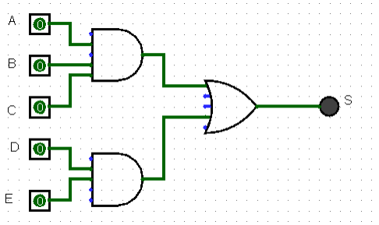

T**abela verdade**

| A | B | C | D | E | S1 (A* B * C) | S2 (D*E) | S(S1 + S2) |
| --- | --- | --- | --- | --- | --- | --- | --- |
| 0 | 0 | 0 | 0 | 1 | 0 | 0 | 0 |
| 0 | 0 | 0 | 0 | 0 | 0 | 0 | 0 |
| 0 | 0 | 0 | 1 | 1 | 0 | 1 | 1 |
| 0 | 0 | 0 | 1 | 0 | 0 | 0 | 0 |
| 0 | 0 | 1 | 0 | 1 | 0 | 0 | 0 |
| 0 | 0 | 1 | 0 | 0 | 0 | 0 | 0 |
| 0 | 0 | 1 | 1 | 1 | 0 | 1 | 1 |
| 0 | 0 | 1 | 1 | 0 | 0 | 0 | 0 |
| 0 | 1 | 0 | 0 | 1 | 0 | 0 | 0 |
| 0 | 1 | 0 | 0 | 0 | 0 | 0 | 0 |
| 0 | 1 | 0 | 1 | 1 | 0 | 1 | 1 |
| 0 | 1 | 0 | 1 | 0 | 0 | 0 | 0 |
| 0 | 1 | 1 | 0 | 1 | 0 | 0 | 0 |
| 0 | 1 | 1 | 0 | 0 | 0 | 0 | 0 |
| 0 | 1 | 1 | 1 | 1 | 0 | 1 | 1 |
| 0 | 1 | 1 | 1 | 0 | 0 | 0 | 0 |
| 1 | 0 | 0 | 0 | 1 | 0 | 0 | 0 |
| 1 | 0 | 0 | 0 | 0 | 0 | 0 | 0 |
| 1 | 0 | 0 | 1 | 1 | 0 | 1 | 1 |
| 1 | 0 | 0 | 1 | 0 | 0 | 0 | 0 |
| 1 | 0 | 1 | 0 | 1 | 0 | 0 | 0 |
| 1 | 0 | 1 | 0 | 0 | 0 | 0 | 0 |
| 1 | 0 | 1 | 1 | 1 | 0 | 1 | 1 |
| 1 | 0 | 1 | 1 | 0 | 0 | 0 | 0 |
| 1 | 1 | 0 | 0 | 1 | 0 | 0 | 0 |
| 1 | 1 | 0 | 0 | 0 | 0 | 0 | 0 |
| 1 | 1 | 0 | 1 | 1 | 0 | 1 | 1 |
| 1 | 1 | 0 | 1 | 0 | 0 | 0 | 0 |
| 1 | 1 | 1 | 0 | 1 | 1 | 0 | 1 |
| 1 | 1 | 1 | 0 | 0 | 1 | 0 | 1 |
| 1 | 1 | 1 | 1 | 1 | 1 | 1 | 1 |
| 1 | 1 | 1 | 1 | 0 | 1 | 0 | 1 |

1. Dada a expressão boolena apresente o circuito e a tabela verdade

**Expressão booleana Circuito**

S = ( AB) + (CD) + (EF)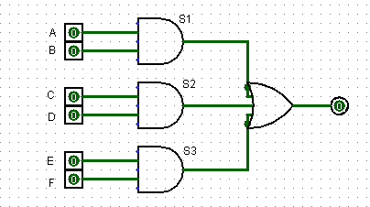

**Tabela verdade**

| A | B | C | D | E | F | S1 (A *B) | S2 (C*D) | S3 (E*F) | S (S1+S2+S3) |
| --- | --- | --- | --- | --- | --- | --- | --- | --- | --- |
| 0 | 0 | 0 | 0 | 0 | 0 | 0 | 0 | 0 | 0 |
| 0 | 0 | 0 | 0 | 0 | 1 | 0 | 0 | 0 | 0 |
| 0 | 0 | 0 | 0 | 1 | 0 | 0 | 0 | 0 | 0 |
| 0 | 0 | 0 | 0 | 1 | 1 | 0 | 0 | 1 | 1 |
| 0 | 0 | 0 | 1 | 0 | 0 | 0 | 0 | 0 | 0 |
| 0 | 0 | 0 | 1 | 0 | 1 | 0 | 0 | 0 | 0 |
| 0 | 0 | 0 | 1 | 1 | 0 | 0 | 0 | 0 | 0 |
| 0 | 0 | 0 | 1 | 1 | 1 | 0 | 0 | 1 | 1 |
| 0 | 0 | 1 | 0 | 0 | 0 | 0 | 0 | 0 | 0 |
| 0 | 0 | 1 | 0 | 0 | 1 | 0 | 0 | 0 | 0 |
| 0 | 0 | 1 | 0 | 1 | 0 | 0 | 0 | 0 | 0 |
| 0 | 0 | 1 | 0 | 1 | 1 | 0 | 0 | 1 | 1 |
| 0 | 0 | 1 | 1 | 0 | 0 | 0 | 1 | 0 | 1 |
| 0 | 0 | 1 | 1 | 0 | 1 | 0 | 1 | 0 | 1 |
| 0 | 0 | 1 | 1 | 1 | 0 | 0 | 1 | 0 | 1 |
| 0 | 0 | 1 | 1 | 1 | 1 | 0 | 1 | 1 | 1 |
| 0 | 1 | 0 | 0 | 0 | 0 | 0 | 0 | 0 | 0 |
| 0 | 1 | 0 | 0 | 0 | 1 | 0 | 0 | 0 | 0 |
| 0 | 1 | 0 | 0 | 1 | 0 | 0 | 0 | 0 | 0 |
| 0 | 1 | 0 | 0 | 1 | 1 | 0 | 0 | 1 | 1 |
| 0 | 1 | 0 | 1 | 0 | 0 | 0 | 0 | 0 | 0 |
| 0 | 1 | 0 | 1 | 0 | 1 | 0 | 0 | 0 | 0 |
| 0 | 1 | 0 | 1 | 1 | 0 | 0 | 0 | 0 | 0 |
| 0 | 1 | 0 | 1 | 1 | 1 | 0 | 0 | 1 | 1 |
| 0 | 1 | 1 | 0 | 0 | 0 | 0 | 0 | 0 | 0 |
| 0 | 1 | 1 | 0 | 0 | 1 | 0 | 0 | 0 | 0 |
| 0 | 1 | 1 | 0 | 1 | 0 | 0 | 0 | 0 | 0 |
| 0 | 1 | 1 | 0 | 1 | 1 | 0 | 0 | 1 | 1 |
| 0 | 1 | 1 | 1 | 0 | 0 | 0 | 1 | 0 | 1 |
| 0 | 1 | 1 | 1 | 0 | 1 | 0 | 1 | 0 | 1 |
| 0 | 1 | 1 | 1 | 1 | 0 | 0 | 1 | 0 | 1 |
| 0 | 1 | 1 | 1 | 1 | 1 | 0 | 1 | 1 | 1 |
| 1 | 0 | 0 | 0 | 0 | 0 | 0 | 0 | 0 | 0 |
| 1 | 0 | 0 | 0 | 0 | 1 | 0 | 0 | 0 | 0 |
| 1 | 0 | 0 | 0 | 1 | 0 | 0 | 0 | 0 | 0 |
| 1 | 0 | 0 | 0 | 1 | 1 | 0 | 0 | 1 | 1 |
| 1 | 0 | 0 | 1 | 0 | 0 | 0 | 0 | 0 | 0 |
| 1 | 0 | 0 | 1 | 0 | 1 | 0 | 0 | 0 | 0 |
| 1 | 0 | 0 | 1 | 1 | 0 | 0 | 0 | 0 | 0 |
| 1 | 0 | 0 | 1 | 1 | 1 | 0 | 0 | 1 | 1 |
| 1 | 0 | 1 | 0 | 0 | 0 | 0 | 0 | 0 | 0 |
| 1 | 0 | 1 | 0 | 0 | 1 | 0 | 0 | 0 | 0 |
| 1 | 0 | 1 | 0 | 1 | 0 | 0 | 0 | 0 | 0 |
| 1 | 0 | 1 | 0 | 1 | 1 | 0 | 0 | 1 | 1 |
| 1 | 0 | 1 | 1 | 0 | 0 | 0 | 1 | 0 | 1 |
| 1 | 0 | 1 | 1 | 0 | 1 | 0 | 1 | 0 | 1 |
| 1 | 0 | 1 | 1 | 1 | 0 | 0 | 1 | 0 | 1 |
| 1 | 0 | 1 | 1 | 1 | 1 | 0 | 1 | 1 | 1 |
| 1 | 1 | 0 | 0 | 0 | 0 | 1 | 0 | 0 | 1 |
| 1 | 1 | 0 | 0 | 0 | 1 | 1 | 0 | 0 | 1 |
| 1 | 1 | 0 | 0 | 1 | 0 | 1 | 0 | 0 | 1 |
| 1 | 1 | 0 | 0 | 1 | 1 | 1 | 0 | 1 | 1 |
| 1 | 1 | 0 | 1 | 0 | 0 | 1 | 0 | 0 | 1 |
| 1 | 1 | 0 | 1 | 0 | 1 | 1 | 0 | 0 | 1 |
| 1 | 1 | 0 | 1 | 1 | 0 | 1 | 0 | 0 | 1 |
| 1 | 1 | 0 | 1 | 1 | 1 | 1 | 0 | 1 | 1 |
| 1 | 1 | 1 | 0 | 0 | 0 | 1 | 0 | 0 | 1 |
| 1 | 1 | 1 | 0 | 0 | 1 | 1 | 0 | 0 | 1 |
| 1 | 1 | 1 | 0 | 1 | 0 | 1 | 0 | 0 | 1 |
| 1 | 1 | 1 | 0 | 1 | 1 | 1 | 0 | 1 | 1 |
| 1 | 1 | 1 | 1 | 0 | 0 | 1 | 1 | 0 | 1 |
| 1 | 1 | 1 | 1 | 0 | 1 | 1 | 1 | 0 | 1 |
| 1 | 1 | 1 | 1 | 1 | 0 | 1 | 1 | 0 | 1 |
| 1 | 1 | 1 | 1 | 1 | 1 | 1 | 1 | 1 | 1 |

1. Dada a tabela verdade a seguir, desenhe o seu circuito lógico e a expressão booleana

**Tabela verdade Circuito**

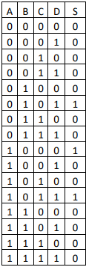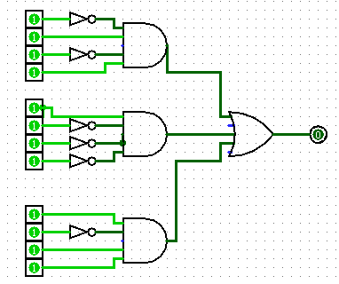

**Expressão booleana**

S=(!A*B*!C*D) + S=(A*!B*!C*!D) +S=(A*!B*C*D)